Health And Safety Policy
Revision 10 – October 2025
Vision Constructions Qld is committed to eliminating hazards and reducing risks to prevent workplace injury, whilst consulting with workers to fulfil compliance and regulatory requirements. We are committed to the continual improvement of the OH&S Management System and its results.

Safety is the first priority in any event and is not sacrificed for any time or money pressures. If works cannot be conducted in a safe manner, than works will not be undertaken. We treat the safety of our individuals with extreme precedence and encourage safe practice both at the workplace and at home.

To ensure that the above commitment is delivered we will:

- Maintain positive and free flowing communication and consulting throughout the company structure enabling improvements to be captured wherever possible.
- Develop, implement and monitor risk management systems for all tasks that are undertaken.
- Establish measurable objectives and targets for health and safety with a view to eliminate work-related injury and illness.
- Constantly review our structures and procedures for improvement.
- Ensure compliance with all relevant health and safety Legislation, Standards, Regulations, statutory obligations and Codes of Practice.
- Actively involve employees, subcontractors, suppliers and clients in the development and ongoing reviews of the safety system. This ensures that the most practical approach is taken and increases the likelihood of acceptance and adherence to the systems.
- Conduct baseline and biennial audiometric testing for workers exposed to high noise levels, ensuring compliance with WHS Regulation Section 58 and supporting safe hearing practices across all worksites.
Safety is the responsibility of every employee. The primary aim is to send each individual home in the same state of health for which they arrived to work.
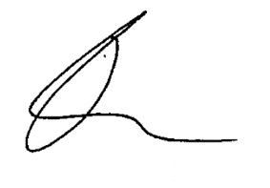

Travis Maher
Managing Director

Date: 22 October 2025

